
Symbiosis Institute of Technology, Pune
CSE- Academic Year 2026-27
Java Programming – Lab Batch 2025-29
Lab Assignment No.: 5
Name of Student | Akshit Gawade
PRN No. | 25070122029
Batch | 2025-2029
Class | A1
Academic Year & Semester | Second Year  Semester III
Date of Submission | 11/7/2026
Title of Assignment: | Develop a Java application demonstrating the use of ArrayList, Vector, and StringBuffer for dynamic data storage, management, and string manipulation.
Problem Statement  Learning  objectives | Develop a Java application demonstrating the use of ArrayList, Vector, and StringBuffer for dynamic data storage,  management, and string manipulation.  To implement dynamic data storage and string manipulation using ArrayList, Vector, and StringBuffer.
Theory | ArrayList and Vector are dynamic array implementations provided by the Java Collections Framework. ArrayList offers faster performance in single-threaded applications, whereas Vector provides synchronized operations for thread safety.  StringBuffer is a mutable sequence of characters that allows efficient string modification without creating new objects.  These classes are commonly used in applications requiring dynamic memory allocation and efficient string processing
Program Code | 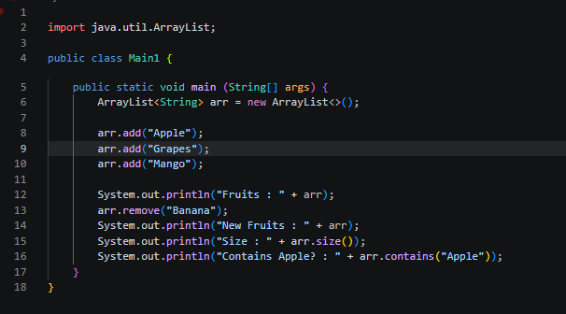  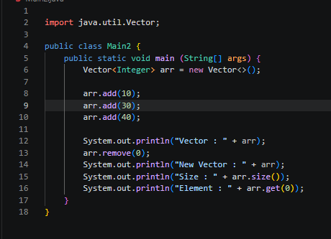  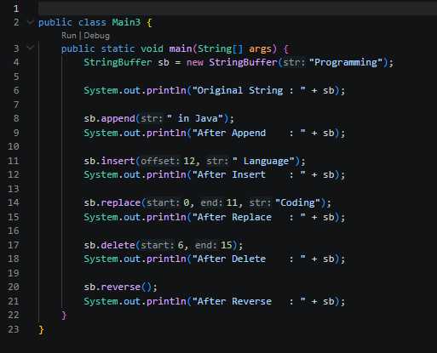  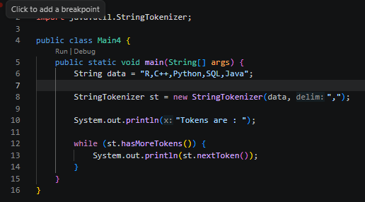
Output Screenshots | 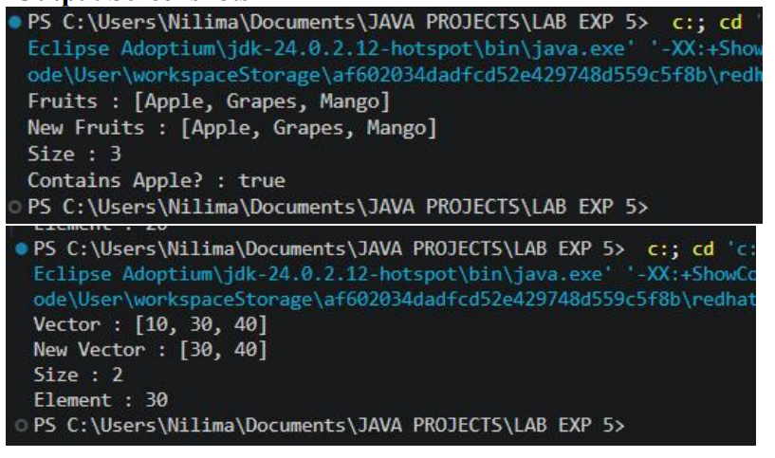  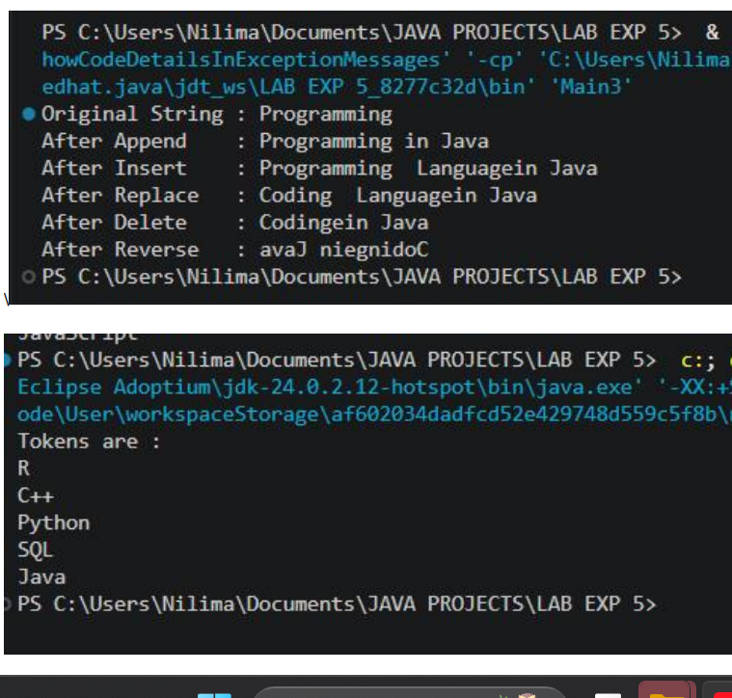
Exercise Qns | Q1. Create a To-Do List application using ArrayList to store tasks and StringBuffer to display tasks.  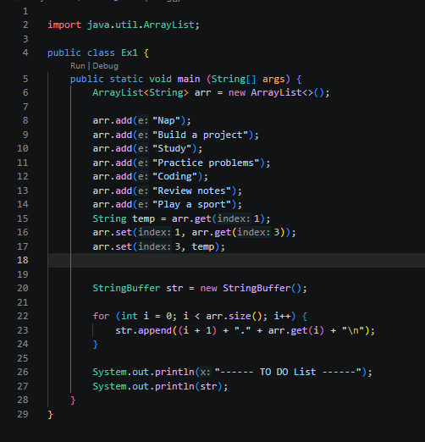  Q2. Create a Student Course Registration System using ArrayList to store the list of courses registered by a student and StringBuffer to generate and display the registered course list. The application should allow users to add, remove, and view registered courses.  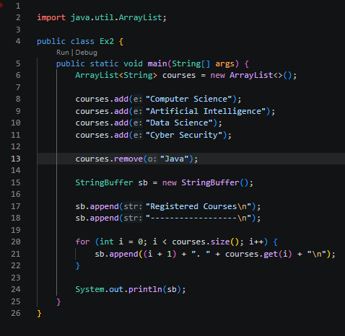
Output Screenshots | 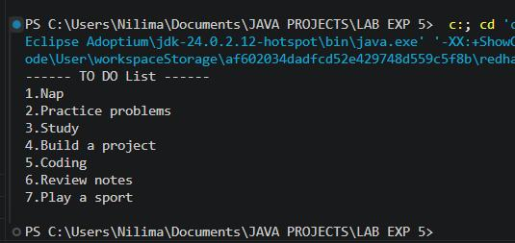  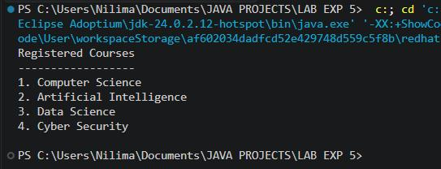
Conclusion | This assignment helped in understanding the use of ArrayList, Vector, and StringBuffer in Java for dynamic data storage, management, and string manipulation. It demonstrated how ArrayList and Vector can efficiently store and  manage collections of data, while StringBuffer enables efficient modification of strings without creating new objects.  The implementation improved my understanding of the Java Collections Framework, dynamic memory management, and mutable string operations. These concepts are widely used in developing desktop applications, web applications,  Android applications, enterprise software, database management systems, and other real-world Java applications that require efficient data handling and string processing.

